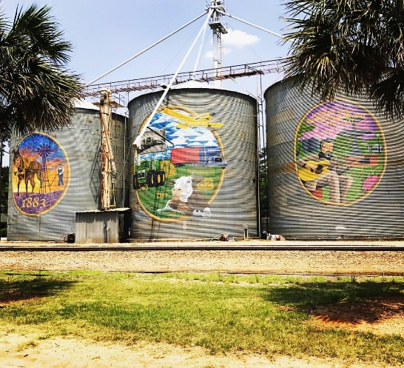

Summary February 03, 2025

Regular Meeting

__________________________________________________________________________

Shellman City Hall 6:00 PM

51 PARK AVENUE

SHELLMAN, GA 39886

1. CALL TO ORDER—MAYOR JAMES WEATHERSBY

|  |  |  |
| --- | --- | --- |
| ATTENDEE NAME | TITLE | STATUS |
| James Weathersby | Mayor | Present |
| Juanita Bradley | Mayor Pro Tem | Present |
| Kelvin Johnson | Councilman | Present |
| Curtis Henderson | Councilman | Present |
| Stewart Short | Councilman | Present |
| Scott Curry | Councilman | Present |

1. **OPENING PRAYER**—Councilman Short
2. **PLEDGE TO THE AMERICAN FLAG**
3. **APPROVAL OF AGENDA** from Feb 3 councilman Short made the motion to approve the agenda and councilman Johnson second. **Motion** **Accepted**
4. **APPROVAL OF MINUTES**

Councilman Short made the motion to accept the minutes from Jan 6**,** 2025and councilman Henderson second. **Motion Accepted**

1. **Approval of Accounts Payable** Councilman Short made the motion to pay all bills and councilman Henderson second. **Accepted**
2. **ANNOUNCEMENTS AND REPORTS**-

* Website Proposal from WTD creating a website for the city of Shellman and Shellman Police
* The mayor stated that he would get Wooten Alley and the road next to Mrs. Lisa Peak scrapped and have gravel put down because these are city streets not publicly owned.

1. The police chief gave his report and is still actively looking for officers to work.
2. **COUNCIL and CITIZEN COMMENTS**-

* The mayor advised the council that the state will be putting signs on Dean St at both ends.
* The railroad crew will be working on the crossing starting Wednesday and will need to detour traffic onto the city streets.
* Councilman Short wants the mayor to speak with Mr. Ted about the ditch on Dean St.
* Councilwoman Bradley asked about code enforcement and storage buildings. She was informed that this does not apply to storage buildings that have been on the property for years. She also asked about the trash pickup on Buford Circle. The truck has not picked up in two weeks due to a line down.
* The mayor advised the council of the letter from Windstream. There was an emergency locate called in but we were informed that they didn’t have anyone in the area to locate for them. The cost of hitting the cable was $11,319.48. We will forward this letter to the attorney and let him handle it.

1. **CONSENT AGENDA (THINGS THAT NEED TO BE VOTED ON)**

* Councilman Short made the motion to move forward with WTD on the city website councilman Henderson second **Motion Passed**
* The tractor trailer ordinance that the city has on file needs to be amended so it will not list a parking lot for the trailers. Councilman Short made a motion to pass. Councilman Henderson seconded. **Motion Passed**
* Consent to dispense with the second reading of the Tractor Trailer Ordinance was put in motion by councilman Short and seconded by councilman Johnson **Motion Passed**

1. **ACTION ITEMS**
2. **Old Business**
3. The Special Master is trying to contact the people that purchased the land but has not been successful. **New Business**

* Mallary Brown has received a grant to provide Randolph County with free dog food and vet services.

1. **EXECUTIVE SESSION**
2. **ADJOURNMENT** Being no further business, the meeting was adjourned at 6:45