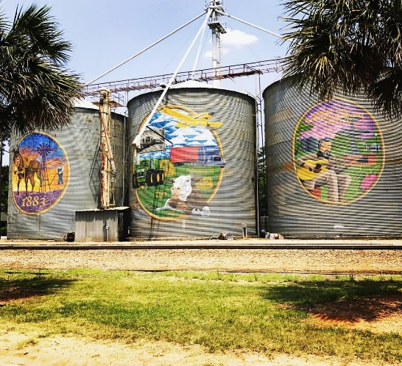

Summary January 03, 2025

Regular Meeting

__________________________________________________________________________

Shellman City Hall 6:00 PM

51 PARK AVENUE

SHELLMAN, GA 39886

1. CALL TO ORDER—MAYOR JAMES WEATHERSBY

|  |  |  |
| --- | --- | --- |
| ATTENDEE NAME | TITLE | STATUS |
| James Weathersby | Mayor | Present |
| Juanita Bradley | Mayor Pro Tem | Present |
| Kelvin Johnson | Councilman | Absent |
| Curtis Henderson | Councilman | Present |
| Stewart Short | Councilman | Present |
| Scott Curry | Councilman | Absent |

1. **OPENING PRAYER**—Councilman Short
2. **PLEDGE TO THE AMERICAN FLAG**
3. **APPROVAL OF AGENDA** from Feb 3 councilwoman Bradley made the motion to approve the agenda and councilman Henderson second. **Motion** **Accepted**
4. **APPROVAL OF MINUTES**

Councilman Short made the motion to accept the minutes from Jan 6**,** 2025and councilman Henderson second. **Motion Accepted**

1. **Approval of Accounts Payable**

Councilman Short made the motion to pay all bills and councilman Henderson second. **Accepted**

1. **ANNOUNCEMENTS AND REPORTS**-

* The Budget is still being looked over.
* Mr. Plowden the Code Enforcer wants to be able to enforce a fine for not complying with the code ordinances and when the ticket is delivered the Chief of Police will go with him. The council agreed that this will ok and the fine minimum is $250.

1. The police chief gave his report and advised the council that he is not able to write tickets on speeding until he receives his permit from GPASS. The chief also told the council that he needs more officers and he was advised to advertise it in the local paper, Facebook, and the Dawson News.
2. **COUNCIL and CITIZEN COMMENTS**-

* The mayor discussed with the council about Club Peaches water hookup. The mayor wants to see if it will be a problem separating the three buildings so that each one will have its own meter. He will monitor the readings for a couple of months to see if the reading is picking the reading up correct.
* Councilman Short advised the chief that he would like to see the dates on his reports and the officer who took the call.
* Councilwoman Bradley reminded everyone about the MLK Parade and that the line up would be at club peaches. She also addressed the chief about having his officers to patrol the area on the one way on Phelps St. people are coming out the wrong way and that may cause an accident.

1. **CONSENT AGENDA (THINGS THAT NEED TO BE VOTED ON)**
2. **ACTION ITEMS**
3. **Old Business**

* The mayor emailed the attorney but hasn’t received a reply as of the time of the meeting.

1. **New Business**

* Information on House Bill 581

1. **EXECUTIVE SESSION**
2. **ADJOURNMENT** Being no further business, the meeting was adjourned at 6:27