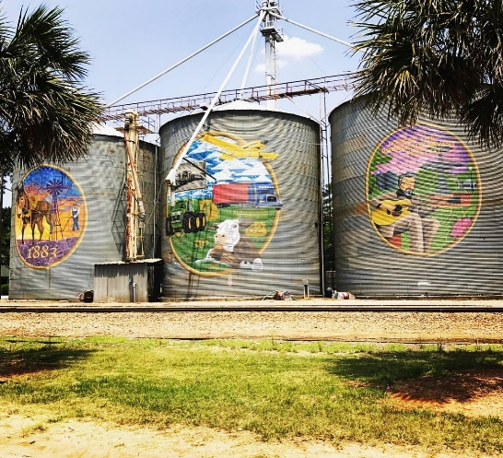

Summary March 3, 2025

Regular Meeting

__________________________________________________________________________

Shellman City Hall 6:00 PM

51 PARK AVENUE

SHELLMAN, GA 39886

1. CALL TO ORDER—MAYOR JAMES WEATHERSBY

|  |  |  |
| --- | --- | --- |
| ATTENDEE NAME | TITLE | STATUS |
| James Weathersby | Mayor | Present |
| Juanita Bradley | Mayor Pro Tem | Present |
| Kelvin Johnson | Councilman | Present |
| Curtis Henderson | Councilman | Present |
| Stewart Short | Councilman | Present |
| Scott Curry | Councilman | Present |

1. **OPENING PRAYER**—Councilman Short
2. **PLEDGE TO THE AMERICAN FLAG**
3. **APPROVAL OF AGENDA** councilwoman Bradley made the motion to approve the agenda and councilman Johnson second. **Motion** **Accepted**
4. **APPROVAL OF MINUTES**

Councilman Curry made the motion to accept the minutes from February 3**,** 2025and councilman Johnson second. **Motion Accepted**

1. **Approval of Accounts Payable** Councilman Curry made the motion to pay all bills and councilman Henderson second. **Accepted**
2. **ANNOUNCEMENTS AND REPORTS**-

* Gas accounts not reading correctly so water and gas consultants will be out checking the meters for accuracy.

1. **COUNCIL and CITIZEN COMMENTS**-

* Sylvia Latimore was on the agenda and she wanted her laundromat to be on a flat rate because the bill is too high. This would include her business, her home and her son’s home. The council said that it could not be put on a flat rate and those three meters will have to be separated. Ms. Latimore stated that the water isn’t good. The mayor assured her that it is tested every month by an outside agency for the state water system and it is safe to drink. She also complained about the rain water running down HWY 41 washing her road out. The mayor advised her that he would give her the name to someone from the state to talk with because that is not on the city.
* Brandon Peak was on the agenda and he was supposed to discuss trailer parking but instead he asked the council about removing the speed bumps that were placed throughout the Blue Bottom area and the trash needs to be picked up in that area also. The mayor and council decided that the speed bumps could be taken up but the city wasn’t the entire reason they were put down. Some of the citizens requested they be installed. Councilman Johnson asked if the ones that were by the softball field stay in place for the sake of the kids playing in that area.
* Councilwoman Bradley asked was Jonathan supposed to be at the meetings to give a report. The mayor advised that he didn’t but if she would like for him to do so he would arrange for that to be done. So, the mayor will tell him to be present at the next meeting. She also asked the clerk if the dates and times for city court were posted for the public. The clerk advised her that they were posted inside and on the outside bulletin board. It is also listed on the ticket of the offender.
* Councilman Henderson mentioned to the police about four wheelers in the street and this needs to be addressed.

1. **CONSENT AGENDA (THINGS THAT NEED TO BE VOTED ON)**
2. **ACTION ITEMS**
3. **Old Business**
4. The Special Master is still trying to contact the people that purchased the land but has not been successful.
5. **New Business**
6. **EXECUTIVE SESSION**
7. **ADJOURNMENT** Being no further business, the meeting was adjourned